

VSSC Nexus Guidelines
Create an Upgrade Request Process

REVISION HISTORY SUMMARY

Date | Version | Changed By | Revision Summary
09/20/13 | 1.0 | Sheetal Swamy | Initial release of document

All printer and scale requests submitted by a Sales AE or CIC should be listed as “Consultation with Hardware”.
If a PID is submitted as a ‘Consultation without Hardware’ DO NOT create an Upgrade request. Follow the instructions outlined to handle the scenarios below:
- If the request is only for JIT/Peripheral, terminate and send FSSC Action email requesting a Consultation with Hardware
- If the request is for both JIT and Training, complete the training and send FSSC Action email requesting a Consultation with Hardware

VSSC will follow current Printer Order guidelines to verify Customer’s address prior to processing the Upgrade request.
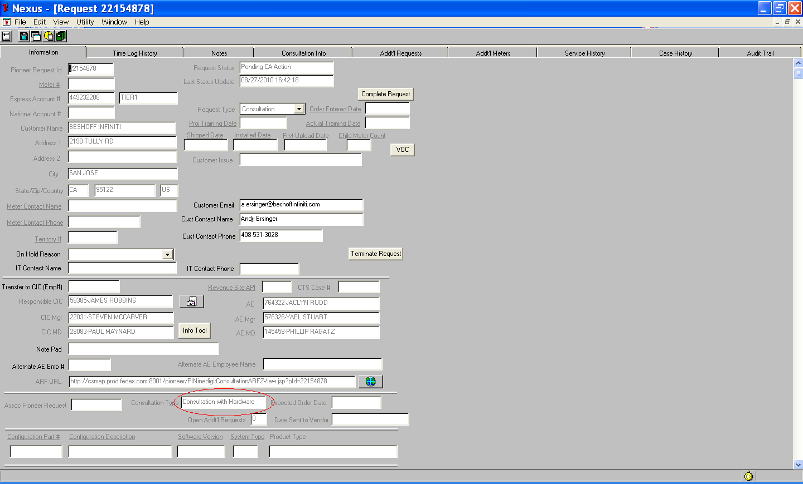
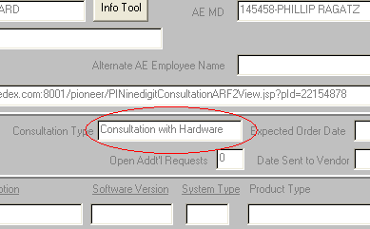

If the Consultation with the customer has been completed or the correct meter number is provided, proceed to the “Consultation Info” tab.
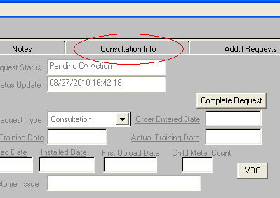

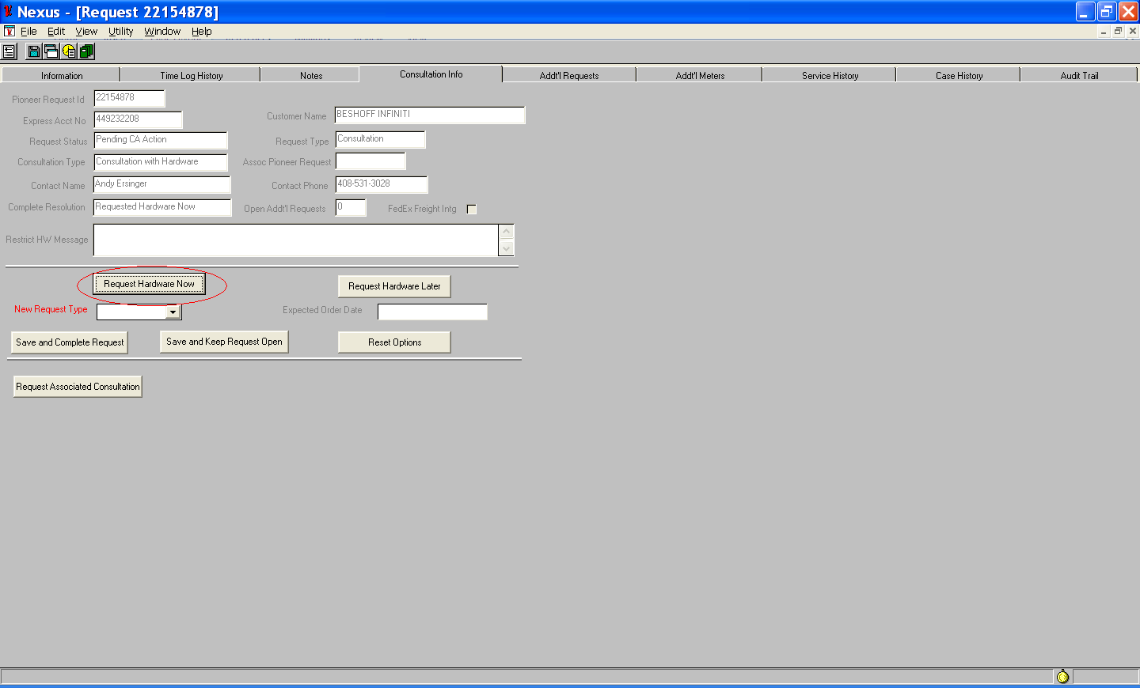

Click on “Request Hardware Now” to enable the “New Request Type” drop down menu.
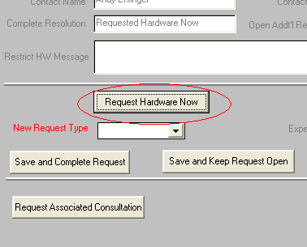

- It is critical for the VSSC to verify that no further action is required on the Upgrade request.
- Select “Upgrade” from the drop down menu. The select “Save and Complete the Request”.
  - If additional training or a Sub-ARF is required, select “Save and Keep Request Open” (This will generate the Upgrade request but will keep the Original PID open).
  - If utilizing both a Sub-ARF and Upgrade request the “Save and Complete Request” option must be selected.
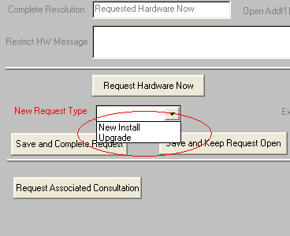

This will create a new pioneer request. This new Upgrade request may be immediately available or it may take a few minutes to appear in your nexus workload. The New Pioneer Request will have a new PID and “Upgrade” as the Request type.
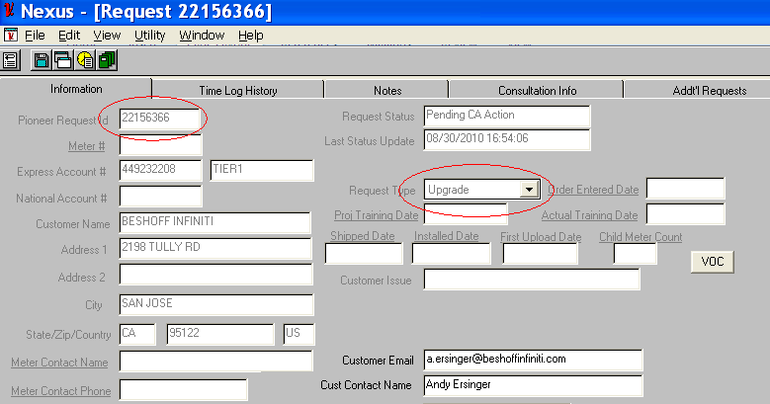

Once the “Upgrade” request is available, order the printer per current ‘Printer Order Process’.

